Multiple choice section

|  |  |  |  |  |  |  |  |  |
| --- | --- | --- | --- | --- | --- | --- | --- | --- |
| Question | 1 | 2 | 3 | 4 | 5 | 6 | 7 | 8 |
| Answer | D | D | B | A | C | D | C | A |

Question 1 [12.1]

D

The equation must not be of the form .

Question 2 [12.4] [10A]

D

81= (92) = 9

Question 3 [12.3]

B

5x5 × 8x3 = 5 × 8 × x5 + 3

= 40x8

Question 4 [12.3]

A

(2x5)4 = 24x5 × 4

= 16x20

Question 5 [12.5] [10A]

C

(1000) = (103)

= 310 = 3

Question 6 [12.5] [10A]

D

= 

= 32

= -2(3) = -2

Question 7 [12.1]

C

The horizontal asymptote is y = 4.

Question 8 [12.3]

A

The graph of the equation is a circle of centre (0, 0) and radius 2.

Multiple-choice results: 8

Short answer section

Question 10 2 marks [12.5] [10A]

In the term 5x6, the ‘x’ is known as the base and 5 is known as the coefficient.

Question 11 1 mark [12.5] [10A]

(81) = 4 because 3 raised to the power 4 equals 81.

Question 12 2 marks [12.4] [10A]

 = 

= 

= 

Question 13 2 marks [12.3]

2*a*3*b*2 = 

Question 14 2 marks [12.3]

(*a*3*b*2)2 = *a*6*b*4

= 

Question 15 6 marks [12.5] [10A]

|  |  |  |
| --- | --- | --- |
| **(a)** (12) + (3) = (12 × 3) = (36) =  = 2(6) = 2 | **(b)** (50) – (10) = = (5) = 1 | **(c)** 3(2) = (23) = (8) = 1 |

Question 16 6 marks [12.2]

**(a)** (*x* + 3)2 + (*y* – 2)2 = 9

**(b)** 3 units left and 2 units up gives a centre of (-3, 2)

**(c)** *r* = 3

**(d)**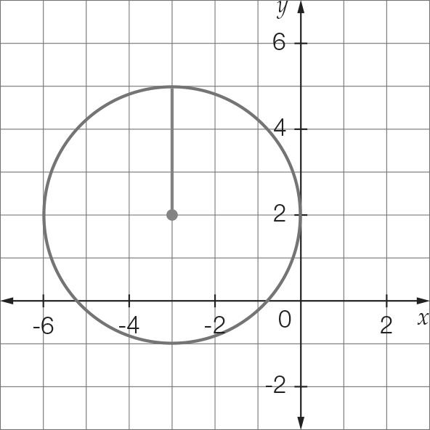

Question 17 4 marks [12.2]

**(a)** *y* = 3(*x* + 1)– 2

**(b)**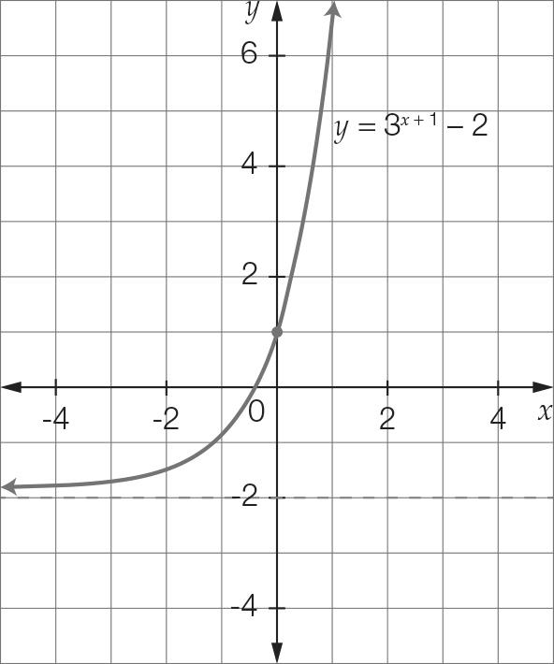

Question 18 6 marks [12.2]

**(a)** *y* =  – 1 **(b)** *x* = 2

**(c)** *y* = -1

**(d)**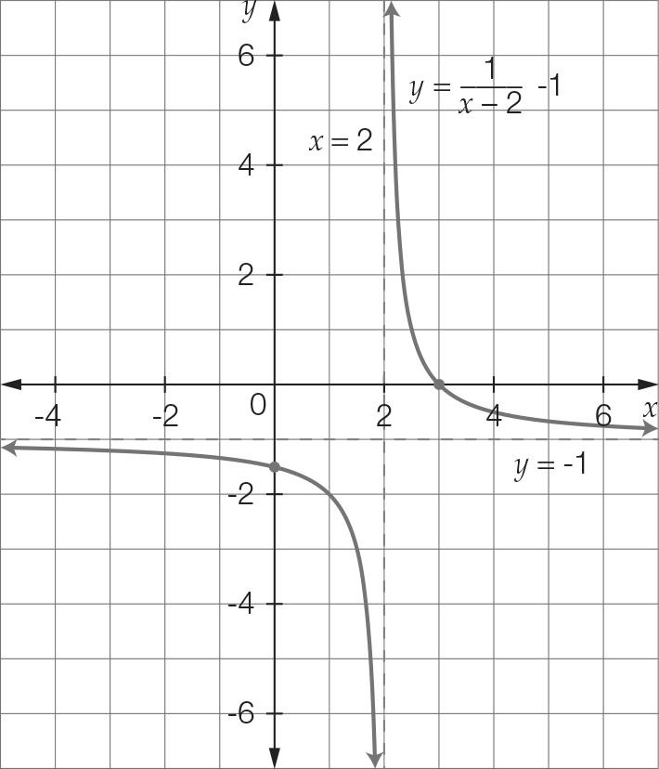

Short answer total: 31

Extended answer section

Question 19 8 marks [12.2]

**(a)** (*x* + 1)2 + (*y* − 2)2 = 16

(b)   
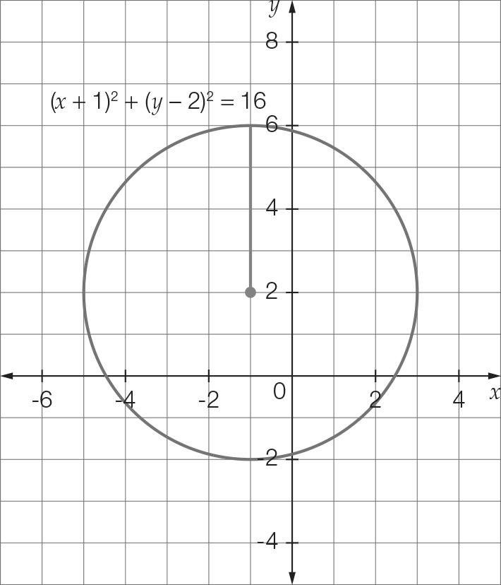

**(c)** r = 4 originally. An increase of 2 units so r = 6  
The new equation is(*x* + 1)2 + (*y* – 2)2 = 36

(d)  
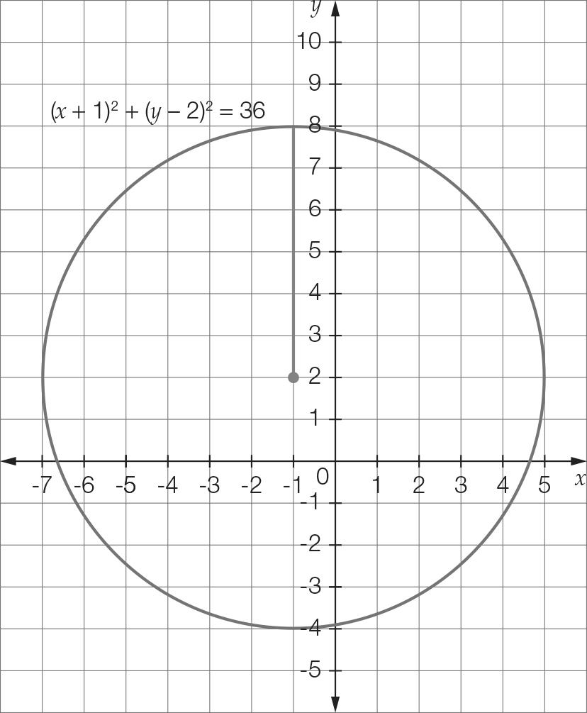

**(e)** The centre is (-1, -2). The radius is unchanged, so r = 6.

Question 20 8 marks [12.2]

**(a)** Initial temperature occurs when t = 0.  
  
For t = 0  
*T* = 20 + 3  
*T* = 1 + 3  
 *T* = 4

So the initial temperature of the vintage clothes iron is 4 °C.

**(b)** For *t* = 2  
*T* = 22+ 3  
*T* = 22+ 3  
 *T* = 4 + 3  
 *T* = 7

So the temperature of the vintage clothes iron after 2 minutes is 7 °C.

**(c)**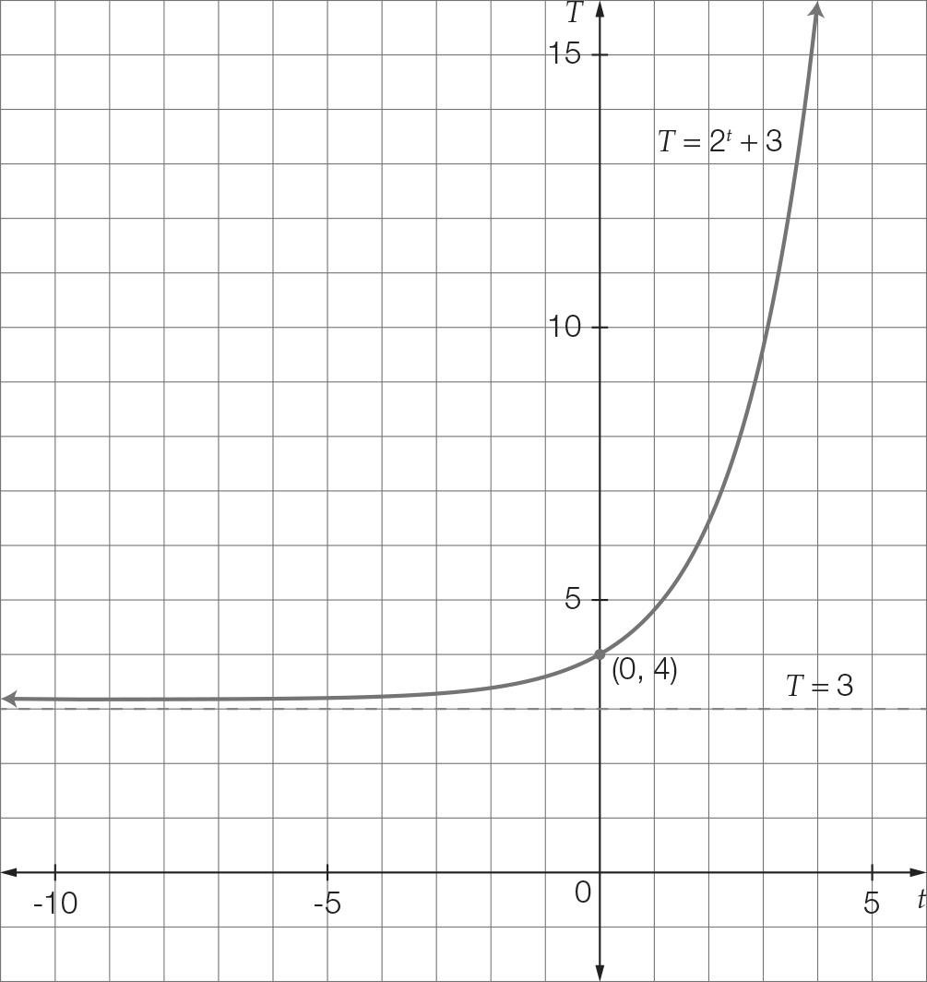

**(d)** For *t* = 5  
*T* = 25 +3  
*T* = 32+3  
*T* = 35 °C  
Temperature difference  
= 35 – 4  
= 31 °C

Extended answer total: 16

TOTAL test results: 55